Assignment02

Predicting firm fast growth : Probability and classification

*by Skirpichnikova Ksenia*

*Oscar Armando Leal Marcos*

Data: “cs_bisnode_panel.csv” file shared for this assignment.

Dataset contains different types of variables indicating financial, management, employment, corporate, industry classification features of companies.

*Label engineering*

What is fast growth? There is no general rule what to consider as a fast growth for business, moreover, it depends on the industry. It is accepted that the company is considered as growing if firm’s growth is higher than for the overall economy. We could have a few options to determine what is a fast growth:

1. To check the growth for the entire sample and choose a rate that is higher than for the entire sample as a fast growth.
2. To check the growth in each industry in the sample and determine the fast growth for each industry separately.
3. If we would know in which countries the firms operated, we could check the economy growth for considered periods and industries and accept the rates that are higher as a fast growth.

For our assignment we decided to calculate the compound annual growth rate[1] for the firms within the period 2010-2015 and considered as fast growth a threshold 15%. The 15% growth in sales may seem as a moderate one, nevertheless, the firm growing at this pace will double its sales within 5 years, that is a definite fast growth. Dependent variable is a binary variable called *fastgrowth*: ‘one’ if compound annual growth rate was higher than or equal to 15% and ‘zero’ when lower.

*Sample design*

We are going to predict fast growth for SME (small and medium enterprise), thus observations with sales higher than 10 million euro of annual sales and less than 10 000 euro were not considered. We are focused on a cross-section of 2015. Also, as we needed the 5 – years compound annual growth, we included only the firms that operated within the entire period and dropped observations with some missing values. As a result, for analysis we have a dataset of 10 564 observations. 27% of the firms have compound annual growth more than 15%.

We look at the distribution of a few basic variables: sales, profit and loss, total assets:

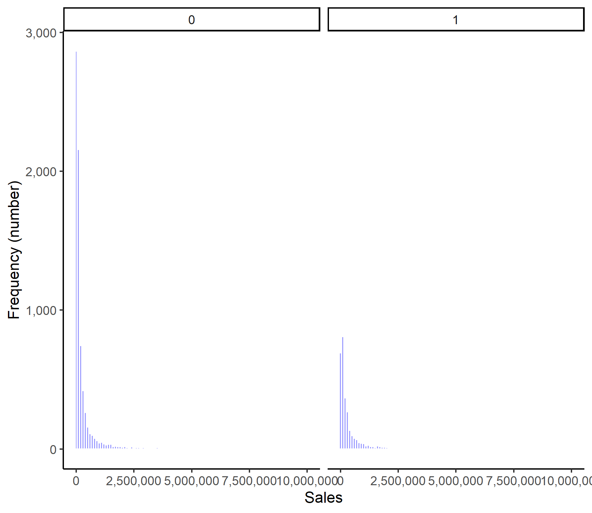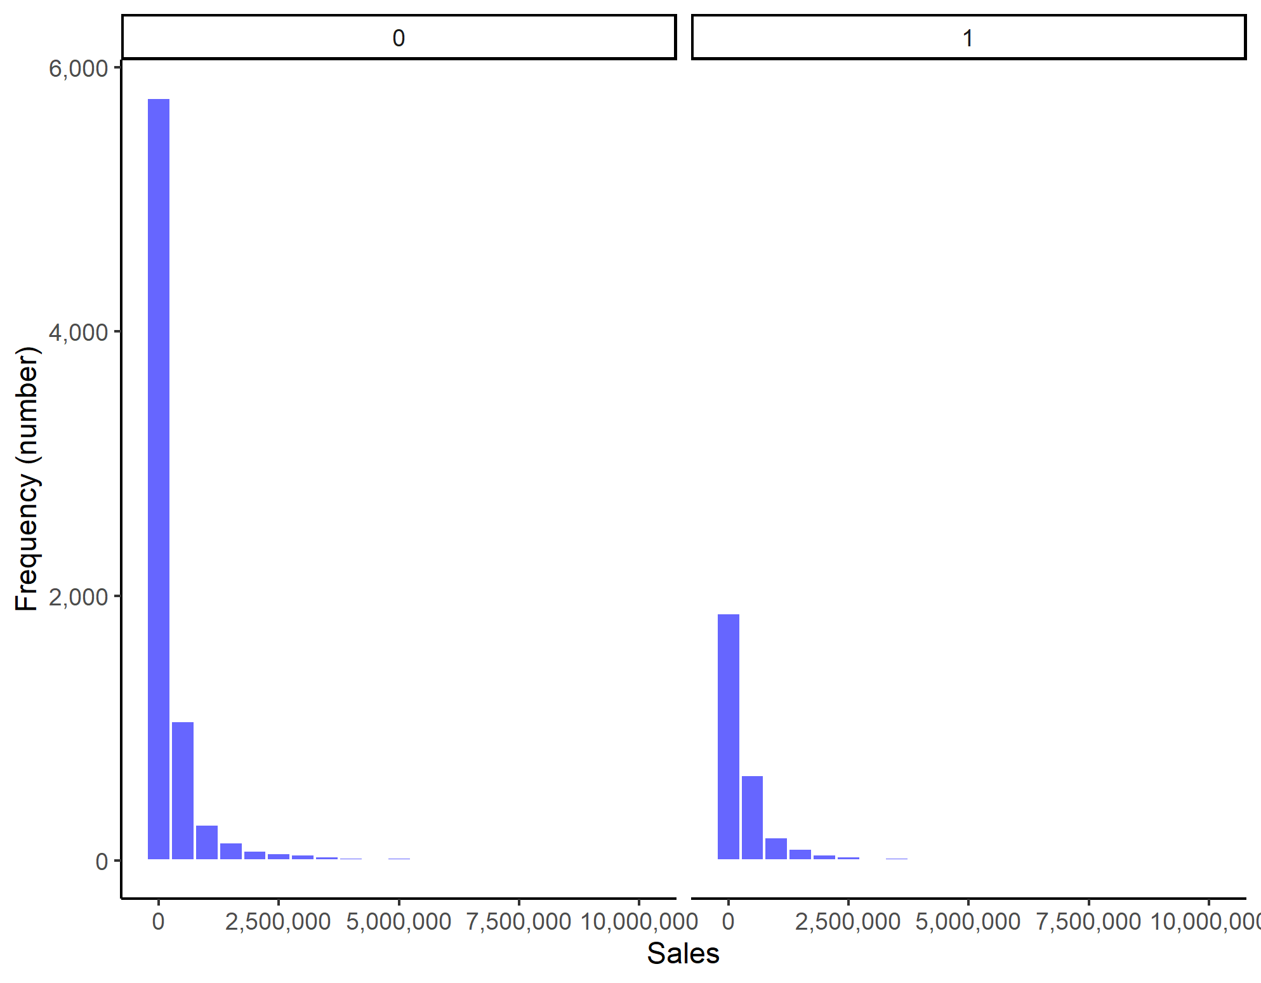

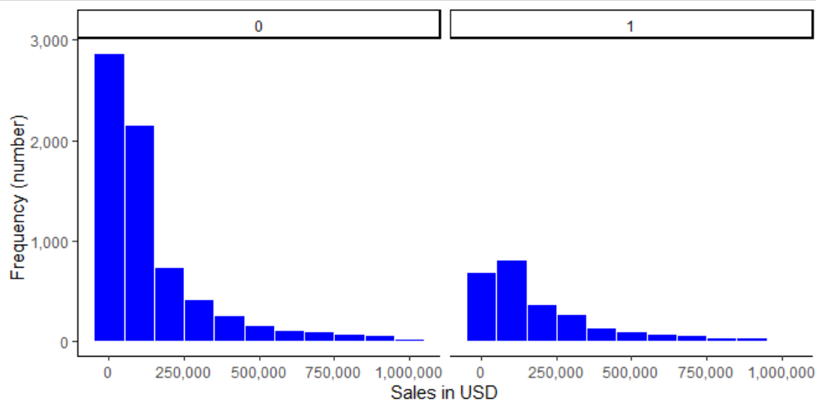

**Not fast growth**

**Fast growth**

(2) Comparison of sales (for firms with sales < 1 mn euro)

Table 01. Descriptive statistics for sales (euro):

|  |  |  |  |  |  |
| --- | --- | --- | --- | --- | --- |
| Min. | 1st Qu. | Median | Mean | 3rd Qu. | Max. |
| 10,000 | 35,291 | 93,715 | 405,547 | 284,115 | 9,964,481 |

The interquartile range for sales is 35,291 – 284,115 euro, median price 93,715 euro, presence in the sample of firms with high sales shifted the average to 405,547 euro.

Based on the plot above we can make an assumption.

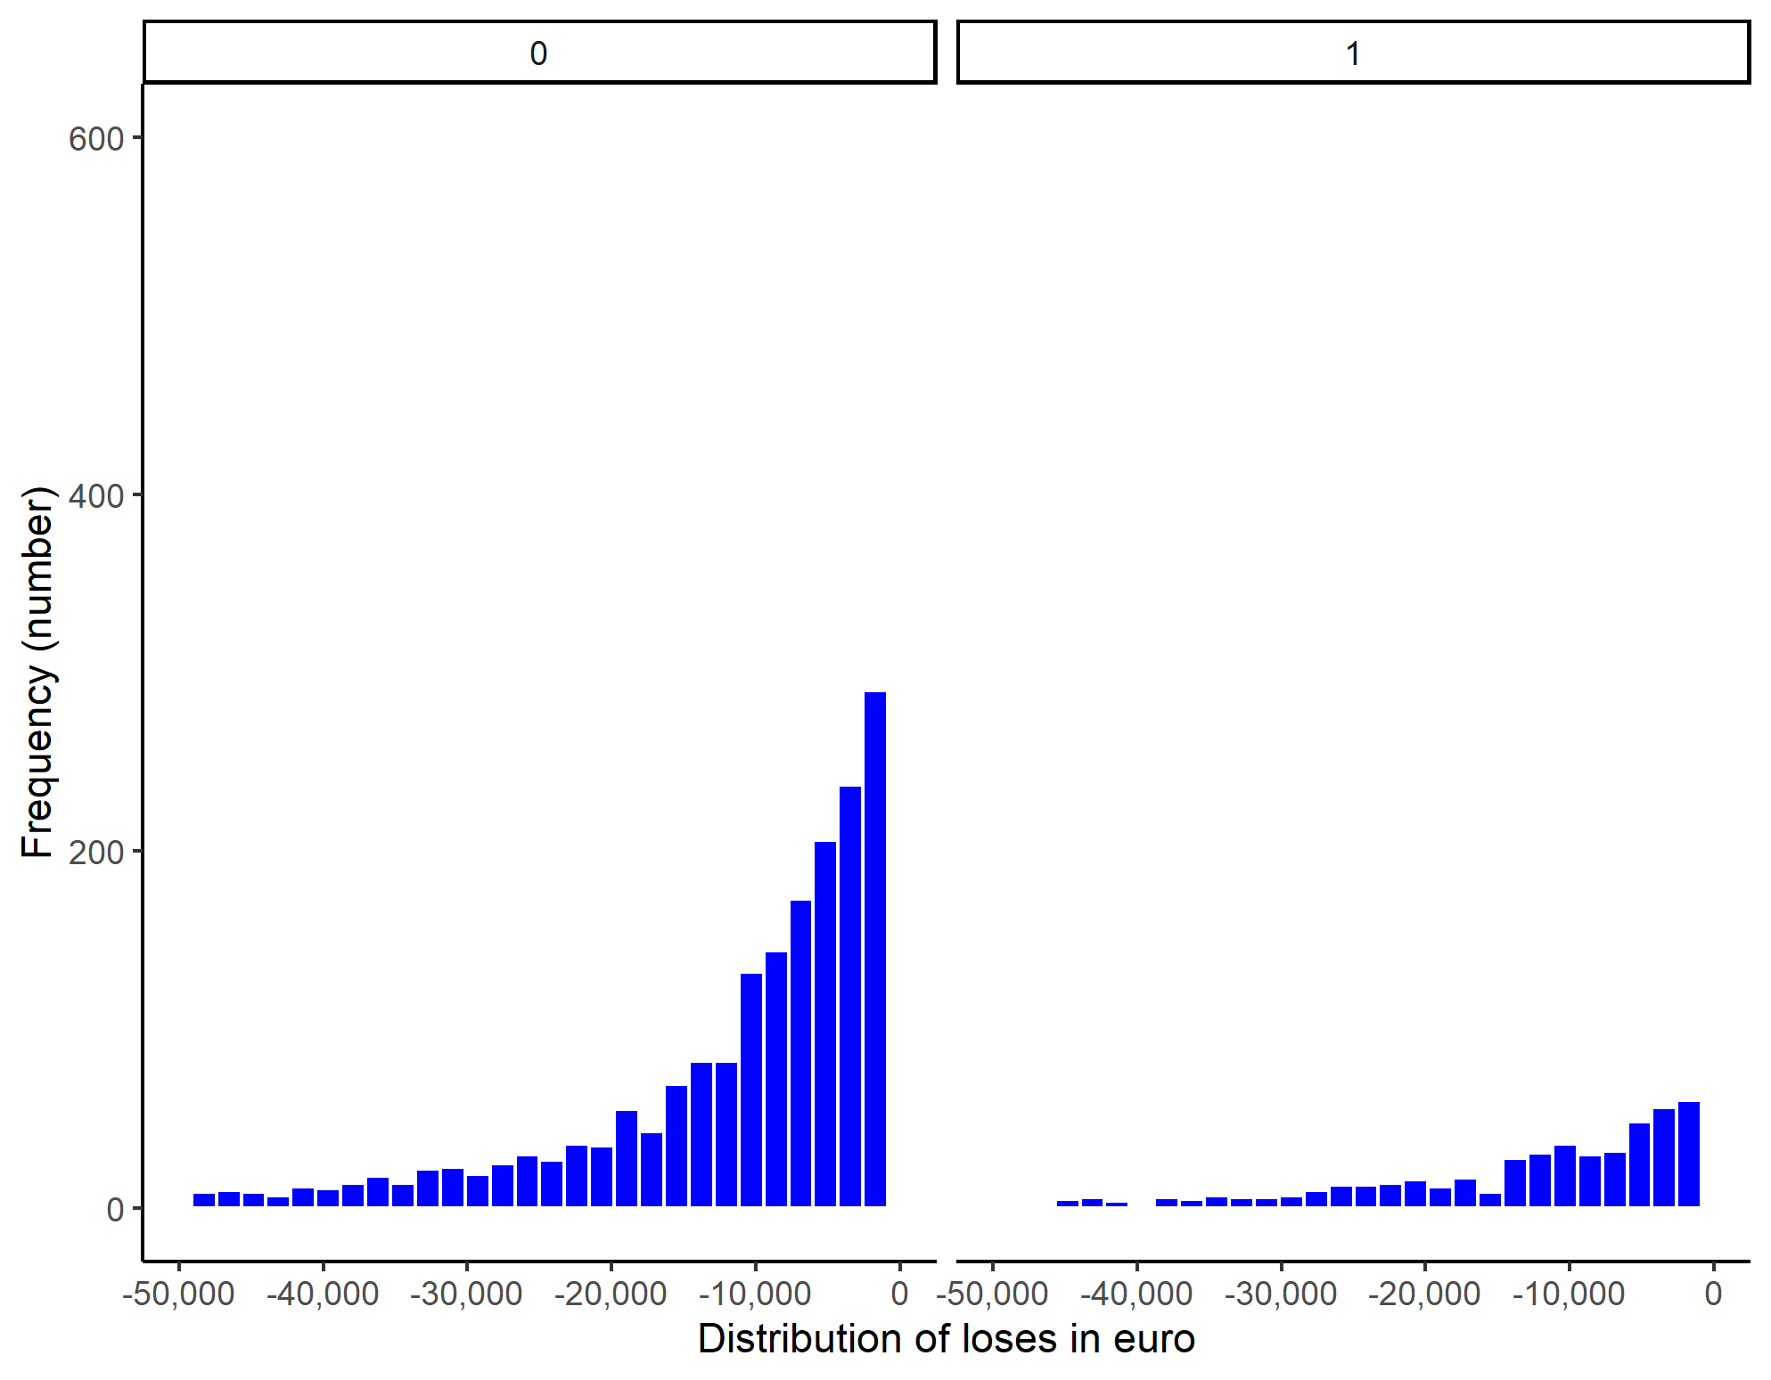

**Not fast growth**

**Fast growth**

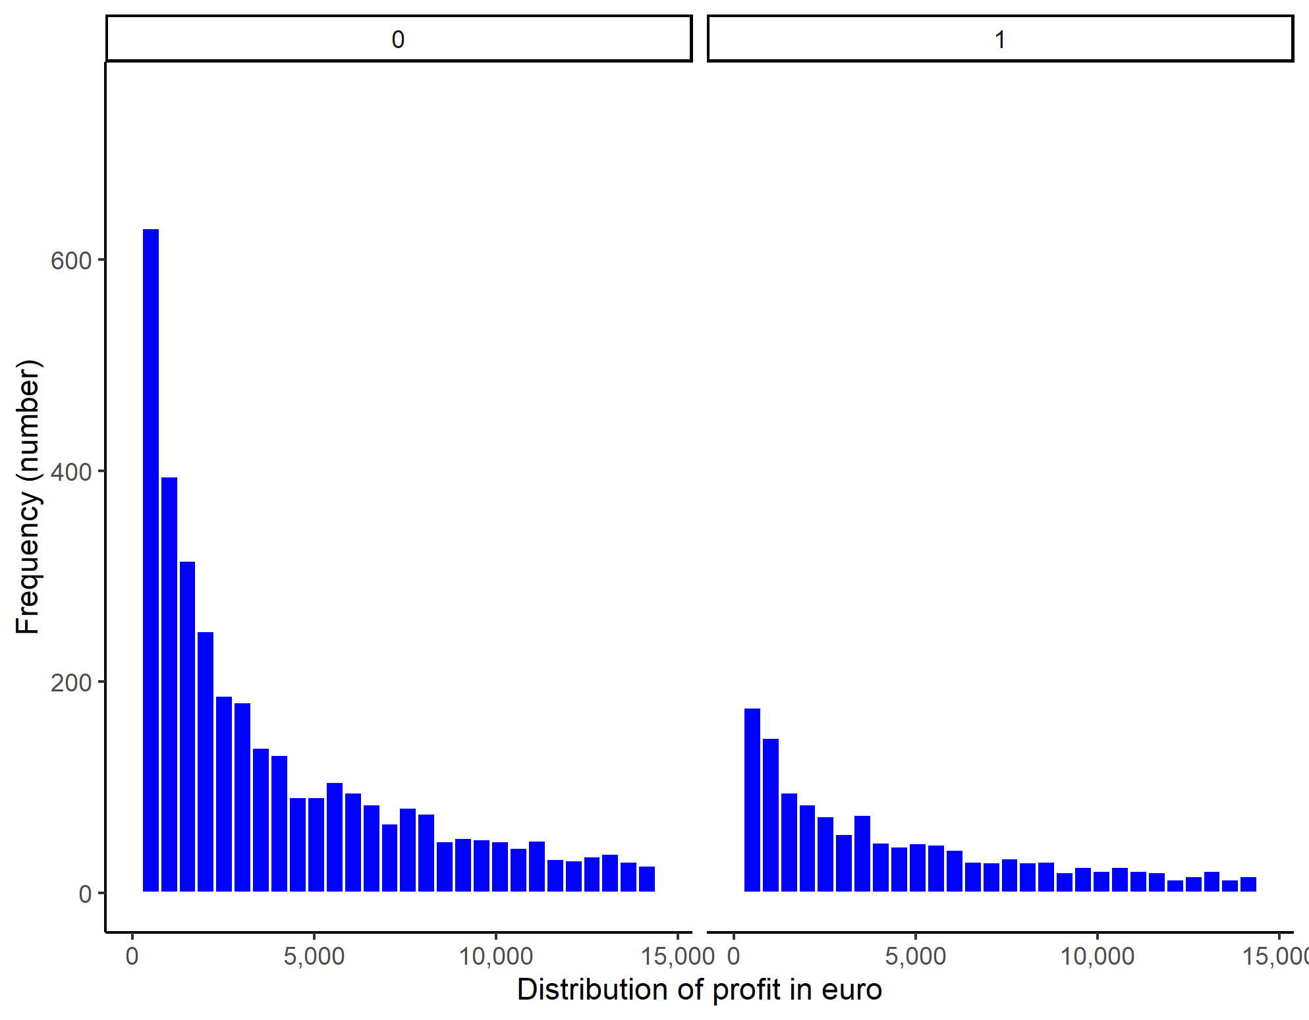

**Not fast growth**

**Fast growth**

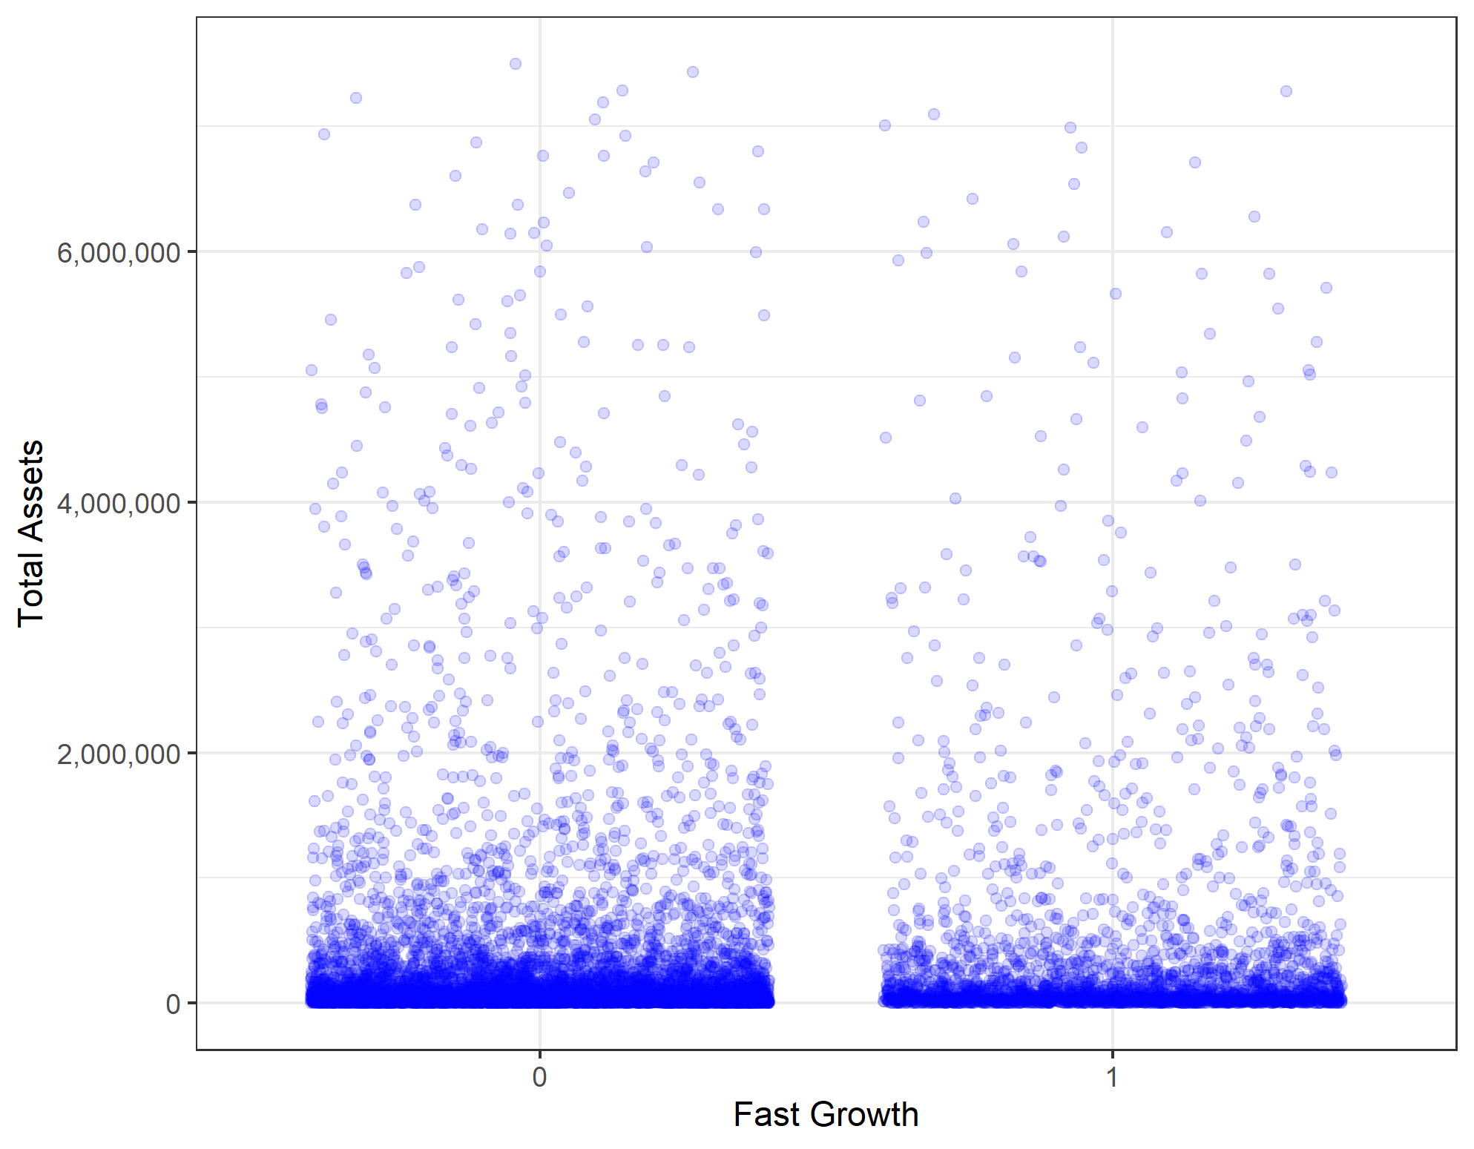

For this assignment we have used the same variables and feature engineering that was used for exit prediction.

Sales: the variable was used in a transformed logarithmic form. Growth was also calculated using logarithmic form of sales.

Industries: out dataset contains 8 categories of industries; variable is a 2 digits NACE industry code.

Financial reports

*PART I Probability prediction*

* Logit M1: handpicked few variables (p=7)
* Logit M2: handpicked few variables + Firm (p=10)
* Logit M3: Firm, Financial 1, Growth (p=68)
* Logit LASSO: M3 + LASSO (p=49)
* Random Forest (no interactions, no modified features besides sales and growth (log transformation))

|  |
| --- |
| M1 <- c("age", "sales_mil_log", "d1_sales_mil_log", "profit_loss_year", "ind2_cat", "ceo_age", "personnel_exp")  M2 <- c("age", "sales_mil_log", "sales_mil_log_sq", "d1_sales_mil_log", "profit_loss_year", "ind2_cat", "ceo_age", "personnel_exp","total_assets_bs", "share_eq" )  M3 <- c("sales_mil_log", "sales_mil_log_sq", firm, engvar, engvar2, engvar3, d1, hr, qualityvars)  # for LASSO  logitvars <- c("sales_mil_log", "sales_mil_log_sq", engvar, engvar2, engvar3, d1, hr, firm, qualityvars, interactions1, interactions2)  # for Random Forest  rfvars <- c("sales_mil_log", "d1_sales_mil_log", rawvars, hr, firm, qualityvars) |

Training dataset contains 8 447 observations (80%), holdout dataset contains 2 111 observations. We did 5-fold cross-validation. Each model was evaluated by its cross-validated average RMSE.

|  |  |  |
| --- | --- | --- |
| Model | Number.of.predictors | CV.RMSE |
| M1 | 7 | 0.4101138 |
| M2 | 10 | 0.4094188 |
| M3 | 68 | 0.3979680 |
| Lasso | 49 | 0.3990162 |
| Random Forest | 34 | 0.3903306 |

After doing a cross-validated performance, we decided to pick Random Forest as our favorite model since it has a considerable amount of predictors, and the RMSE is the lowest.

|  |  |
| --- | --- |
|  |  |

The variables describing scale and maturity of a firm have higher importance for predicting fast growth. The most important variable for fast growth is a log transformed variable indicating growth for the last year. Next two variables describe age of a firm in absolute value and quadratic form. Then we have variables for expenses for materials, profit or loss amount, sales amount, personnel expenses, age of CEO, income before tax, shareholder equity. Importance of these variables is relatively high (~40%) in comparison with growth for the last year.

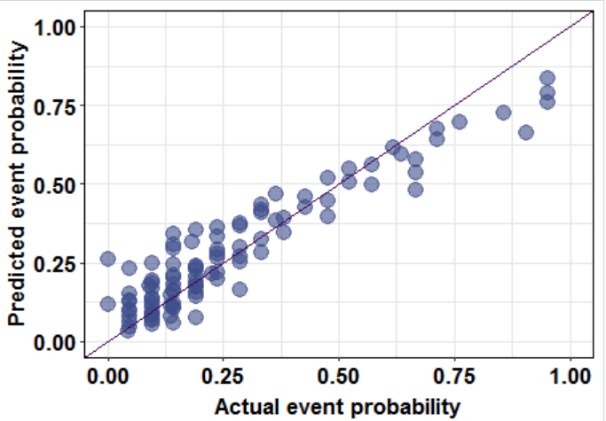

Calibration curve for Random Forest

We plotted calibration plot for Random Forest on holdout dataset, observations were grouped (n=100). Based on the plot we can say that for firms where higher probability was predicted more firms actually were fast growing than we predicted, thus, we did not capture some fast growing firms. It can be that their fast growth can be explained by features we did not include in our model/did not have in our dataset.

*PART II Classification*

For classification we have the loss function: FP = 10, FN = 2.

If the model predicts that a firm has a fast growth, but it is actually NOT a fast growth by the definition of compound annual growth rate for the last 5 years (a false positive), then we lose 10 thousand euros.

If the model predicts that a firm doesn’t have a fast growth, but it is actually growing fast by the definition of compound annual growth rate for the last 5 years (a false negative), then we lose 2 thousand euros.

With correct decisions, we don’t have any loss.

For each model we predicted probabilities, and looked for the optimal classification threshold, calculating expected loss.

We run the threshold selection algorithm on the work set, with 5 - fold cross validation.

Finding the best threshold using lost function (example, 5th fold):

|  |  |
| --- | --- |
|  |  |
| M1 loss function | M1 ROC curve |
|  |  |
|  |  |
| M2 loss function | M2 ROC curve |
|  |  |
|  |  |
| M3 loss function | M3 ROC curve |
|  |  |
|  |  |
| LASSO loss function | LASSO ROC curve |
|  |  |
|  |  |
| Random Forest loss function | Random Forest ROC curve |
|  |  |

Optimal classification threshold is very high for logit models, it is ~100%. It means that to

have lowest expected loss we need to classify as “fast growth” only if predicted probability

was close to 1. Based on given loss function we do not tolerate true negative at all.

Therefore, with Random Forest model the optimal threshold of it is 69%, we can classify a firm as a true “fast growth” if the predicted probability was higher than 0.69.

The best final threshold is the average among best thresholds for each fold. Estimation of expected loss was done on holdout set.

Best model is Random Forest with the smallest average (over 5 folds) expected loss for 0.506

Threshold Expected.loss Holdout RMSE

Logit M1 0.8200587 0.5476078 0.4104147

Logit M2 0.8601644 0.5466604 0.4097237

Logit M3 0.9066177 0.5400284 0.3979703

Logit LASSO 0.8946155 0.5381336 0.3984113

Random Forest 0.7183525 0.5059214 0.3908759

*PART III Discussion of results*

|  |  |  |  |  |
| --- | --- | --- | --- | --- |
| Threshold =69% | | | | Total |
|  |  | Actual | |
|  |  | no_fast | fast |
| predicted | no_fast | 1,521 | 509 | 2,030 |
| fast | 5 | 76 | 81 |
| Total | | 1,526 | 585 | 2,111 |
|  |  |  |  |  |
| Threshold =69% | | | | Total |
|  |  | Actual | |
|  |  | no_fast | fast |
| predicted | no_fast | 99.7% | 87.0% | 96.2% |
| fast | 0.3% | 13.0% | 3.8% |
| Total | | 100% | 100% | 100% |
|  |  |  |  |  |

The rate for false positive is 0.3% and the rate for false negative is 87%. Thus, applying loss function we can calculate that the smallest average expected loss is 0.506.

Thus, building a better model could mean saving 41.68 euro /one observations:

((0.5476078 - 0.5059214)*1000 euro) for a company who is interested in better classification is a certain firm will have fast growth or not (Random forest vs Logit M1).

If such company estimates 1 000 firms, it means it is saving 41 680 euro if the Random Forest is chosen for this particular scenario instead of Logit M1.

1. Compound annual growth rate is a business and investing specific term for the geometric progression ratio that provides a constant rate of return over the time period.